旧县河河道管理范围划定图集

广东粤水电勘察设计有限公司
2020年10月

目录
序号 | 图名 | 图幅
1 | 旧县河河道管理控制点坐标表（右河） | A3
2 | 旧县河河道管理控制点坐标表（左河） | A3
3 | 旧县河河道管理范围线总平面布置图 | A3
4 | 旧县河河道管理范围线平面布置图（1/20） | A3
5 | 旧县河河道管理范围线平面布置图（2/20） | A3
6 | 旧县河河道管理范围线平面布置图（3/20） | A3
7 | 旧县河河道管理范围线平面布置图（4/20） | A3
8 | 旧县河河道管理范围线平面布置图（5/20） | A3
9 | 旧县河河道管理范围线平面布置图（6/20） | A3
10 | 旧县河河道管理范围线平面布置图（7/20） | A3
11 | 旧县河河道管理范围线平面布置图（8/20） | A3
12 | 旧县河河道管理范围线平面布置图（9/20） | A3
13 | 旧县河河道管理范围线平面布置图（10/20） | A3
14 | 旧县河河道管理范围线平面布置图（11/20） | A3
15 | 旧县河河道管理范围线平面布置图（12/20） | A3
16 | 旧县河河道管理范围线平面布置图（13/20） | A3
17 | 旧县河河道管理范围线平面布置图（14/20） | A3
18 | 旧县河河道管理范围线平面布置图（15/20） | A3
19 | 旧县河河道管理范围线平面布置图（16/20） | A3
20 | 旧县河河道管理范围线平面布置图（17/20） | A3
21 | 旧县河河道管理范围线平面布置图（18/20） | A3
22 | 旧县河河道管理范围线平面布置图（19/20） | A3
23 | 旧县河河道管理范围线平面布置图（20/20） | A3

旧县河河道管理控制点坐标表（右河）
河道  名称 | 河道  编号 | 岸别 | 防洪标准 | 控制点坐标 |  |  | 河道  名称 | 河道  编号 | 岸别 | 防洪标准 | 控制点坐标 |  |  | 河道  名称 | 河道  编号 | 岸别 | 防洪标准 | 控制点坐标 |  |  | 河道  名称 | 河道  编号 | 岸别 | 防洪标准 | 控制点坐标
 |  |  |  | x | y |  |  |  |  |  | x | y |  |  |  |  |  | x | y |  |  |  |  |  | x | y
旧县河 | YH001 | 右岸 | 20 | 427276.5651 | 2351310.601 |  | 旧县河 | YH044 | 右岸 | 20 | 424329.7705 | 2346569.296 |  | 旧县河 | YH087 | 右岸 | 20 | 424069.7792 | 2342968.985 |  | 旧县河 | YH130 | 右岸 | 20 | 423345.1211 | 2338416.726
旧县河 | YH002 | 右岸 | 20 | 427111.3037 | 2351311.989 |  | 旧县河 | YH045 | 右岸 | 20 | 424476.2585 | 2346560.651 |  | 旧县河 | YH088 | 右岸 | 20 | 424012.7818 | 2342810.702 |  | 旧县河 | YH131 | 右岸 | 20 | 423374.2592 | 2338272.856
旧县河 | YH003 | 右岸 | 20 | 426934.6925 | 2351263.282 |  | 旧县河 | YH046 | 右岸 | 20 | 424406.4232 | 2346419.067 |  | 旧县河 | YH089 | 右岸 | 20 | 424108.796 | 2342682.363 |  | 旧县河 | YH132 | 右岸 | 20 | 423403.8676 | 2338119.011
旧县河 | YH004 | 右岸 | 20 | 426755.1217 | 2351213.217 |  | 旧县河 | YH047 | 右岸 | 20 | 424265.907 | 2346470.128 |  | 旧县河 | YH090 | 右岸 | 20 | 424212.9869 | 2342572.405 |  | 旧县河 | YH133 | 右岸 | 20 | 423512.289 | 2337978.189
旧县河 | YH005 | 右岸 | 20 | 426644.7518 | 2351148.749 |  | 旧县河 | YH048 | 右岸 | 20 | 424161.1612 | 2346404.204 |  | 旧县河 | YH091 | 右岸 | 20 | 424255.8273 | 2342426.431 |  | 旧县河 | YH134 | 右岸 | 20 | 423655.7692 | 2337920.678
旧县河 | YH006 | 右岸 | 20 | 426515.5087 | 2351053.302 |  | 旧县河 | YH049 | 右岸 | 20 | 424139.7182 | 2346249.041 |  | 旧县河 | YH092 | 右岸 | 20 | 424306.2019 | 2342308.28 |  | 旧县河 | YH135 | 右岸 | 20 | 423743.1725 | 2337794.603
旧县河 | YH007 | 右岸 | 20 | 426324.1662 | 2351024.501 |  | 旧县河 | YH050 | 右岸 | 20 | 424190.7977 | 2346109.173 |  | 旧县河 | YH093 | 右岸 | 20 | 424421.6722 | 2342175.702 |  | 旧县河 | YH136 | 右岸 | 20 | 423856.0834 | 2337685.688
旧县河 | YH008 | 右岸 | 20 | 426186.711 | 2351031.812 |  | 旧县河 | YH051 | 右岸 | 20 | 424343.4446 | 2346106.007 |  | 旧县河 | YH094 | 右岸 | 20 | 424555.8838 | 2342110.11 |  | 旧县河 | YH137 | 右岸 | 20 | 423853.8511 | 2337502.45
旧县河 | YH009 | 右岸 | 20 | 426025.9521 | 2351001.997 |  | 旧县河 | YH052 | 右岸 | 20 | 424445.8345 | 2346177.36 |  | 旧县河 | YH095 | 右岸 | 20 | 424671.9269 | 2342011.987 |  | 旧县河 | YH138 | 右岸 | 20 | 423778.0657 | 2337380.524
旧县河 | YH010 | 右岸 | 20 | 425929.5345 | 2350945.742 |  | 旧县河 | YH053 | 右岸 | 20 | 424504.8106 | 2346026.002 |  | 旧县河 | YH096 | 右岸 | 20 | 424530.2476 | 2341939.743 |  | 旧县河 | YH139 | 右岸 | 20 | 423860.0124 | 2337256.563
旧县河 | YH011 | 右岸 | 20 | 425828.2626 | 2350842.265 |  | 旧县河 | YH054 | 右岸 | 20 | 424548.9967 | 2345884.689 |  | 旧县河 | YH097 | 右岸 | 20 | 424501.2091 | 2341776.718 |  | 旧县河 | YH140 | 右岸 | 20 | 424009.8643 | 2337215.427
旧县河 | YH012 | 右岸 | 20 | 425764.3514 | 2350688.46 |  | 旧县河 | YH055 | 右岸 | 20 | 424682.7505 | 2345801.865 |  | 旧县河 | YH098 | 右岸 | 20 | 424433.5759 | 2341609.418 |  | 旧县河 | YH141 | 右岸 | 20 | 424180.7542 | 2337157.687
旧县河 | YH013 | 右岸 | 20 | 425721.3889 | 2350525.776 |  | 旧县河 | YH056 | 右岸 | 20 | 424749.2606 | 2345669.64 |  | 旧县河 | YH099 | 右岸 | 20 | 424377.4494 | 2341459.979 |  | 旧县河 | YH142 | 右岸 | 20 | 424302.8918 | 2337085.713
旧县河 | YH014 | 右岸 | 20 | 425693.1553 | 2350358.767 |  | 旧县河 | YH057 | 右岸 | 20 | 424903.9673 | 2345561.505 |  | 旧县河 | YH100 | 右岸 | 20 | 424462.8403 | 2341336.607 |  | 旧县河 | YH143 | 右岸 | 20 | 424408.8908 | 2336972.346
旧县河 | YH015 | 右岸 | 20 | 425663.0222 | 2350192.159 |  | 旧县河 | YH058 | 右岸 | 20 | 425056.2546 | 2345511.221 |  | 旧县河 | YH101 | 右岸 | 20 | 424524.9248 | 2341179.517 |  | 旧县河 | YH144 | 右岸 | 20 | 424424.4735 | 2336827.774
旧县河 | YH016 | 右岸 | 20 | 425611.29 | 2350053.897 |  | 旧县河 | YH059 | 右岸 | 20 | 425106.8269 | 2345371.02 |  | 旧县河 | YH102 | 右岸 | 20 | 424577.3623 | 2341028.263 |  | 旧县河 | YH145 | 右岸 | 20 | 424472.6737 | 2336671.061
旧县河 | YH017 | 右岸 | 20 | 425520.9888 | 2349922.427 |  | 旧县河 | YH060 | 右岸 | 20 | 425090.2421 | 2345204.235 |  | 旧县河 | YH103 | 右岸 | 20 | 424585.4786 | 2340937.639 |  | 旧县河 | YH146 | 右岸 | 20 | 424506.7244 | 2336504.269
旧县河 | YH018 | 右岸 | 20 | 425379.2158 | 2349837.671 |  | 旧县河 | YH061 | 右岸 | 20 | 424960.6058 | 2345173.118 |  | 旧县河 | YH104 | 右岸 | 20 | 424480.1127 | 2340820.971 |  | 旧县河 | YH147 | 右岸 | 20 | 424574.3621 | 2336358.853
旧县河 | YH019 | 右岸 | 20 | 425321.7301 | 2349701.013 |  | 旧县河 | YH062 | 右岸 | 20 | 424946.0997 | 2345028.068 |  | 旧县河 | YH105 | 右岸 | 20 | 424553.3975 | 2340730.838 |  | 旧县河 | YH148 | 右岸 | 20 | 424720.2096 | 2336317.785
旧县河 | YH020 | 右岸 | 20 | 425357.9681 | 2349536.77 |  | 旧县河 | YH063 | 右岸 | 20 | 424994.1113 | 2344879.982 |  | 旧县河 | YH106 | 右岸 | 20 | 424461.0918 | 2340625.064 |  | 旧县河 | YH149 | 右岸 | 20 | 424840.1869 | 2336334.091
旧县河 | YH021 | 右岸 | 20 | 425367.5508 | 2349374.719 |  | 旧县河 | YH064 | 右岸 | 20 | 424934.5749 | 2344749.988 |  | 旧县河 | YH107 | 右岸 | 20 | 424366.845 | 2340662.345 |  | 旧县河 | YH150 | 右岸 | 20 | 425004.7191 | 2336426.381
旧县河 | YH022 | 右岸 | 20 | 425365.0036 | 2349208.806 |  | 旧县河 | YH065 | 右岸 | 20 | 424805.0994 | 2344665.006 |  | 旧县河 | YH108 | 右岸 | 20 | 424237.6044 | 2340632.981 |  | 旧县河 | YH151 | 右岸 | 20 | 425035.2808 | 2336317.554
旧县河 | YH023 | 右岸 | 20 | 425332.5603 | 2349034.468 |  | 旧县河 | YH066 | 右岸 | 20 | 424651.8476 | 2344636.092 |  | 旧县河 | YH109 | 右岸 | 20 | 424089.7549 | 2340549.315 |  | 旧县河 | YH152 | 右岸 | 20 | 425085.381 | 2336209.362
旧县河 | YH024 | 右岸 | 20 | 425215.2825 | 2348973.312 |  | 旧县河 | YH067 | 右岸 | 20 | 424512.3156 | 2344581.119 |  | 旧县河 | YH110 | 右岸 | 20 | 424019.5621 | 2340569.881 |  | 旧县河 | YH153 | 右岸 | 20 | 425247.4109 | 2336097.878
旧县河 | YH025 | 右岸 | 20 | 425046.5055 | 2348992.347 |  | 旧县河 | YH068 | 右岸 | 20 | 424444.9357 | 2344428.235 |  | 旧县河 | YH111 | 右岸 | 20 | 423951.6724 | 2340697.033 |  | 旧县河 | YH154 | 右岸 | 20 | 425410.4366 | 2335981.741
旧县河 | YH026 | 右岸 | 20 | 424912.0526 | 2348944.687 |  | 旧县河 | YH069 | 右岸 | 20 | 424334.4058 | 2344362.042 |  | 旧县河 | YH112 | 右岸 | 20 | 423872.2174 | 2340541.828 |  | 旧县河 | YH155 | 右岸 | 20 | 425532.4752 | 2335835.35
旧县河 | YH027 | 右岸 | 20 | 424893.7362 | 2348836.552 |  | 旧县河 | YH070 | 右岸 | 20 | 424190.9676 | 2344324.583 |  | 旧县河 | YH113 | 右岸 | 20 | 423731.6546 | 2340527.629 |  | 旧县河 | YH156 | 右岸 | 20 | 425653.7588 | 2335777.851
旧县河 | YH028 | 右岸 | 20 | 424926.8756 | 2348660.553 |  | 旧县河 | YH071 | 右岸 | 20 | 424030.5968 | 2344323.951 |  | 旧县河 | YH114 | 右岸 | 20 | 423601.1727 | 2340428.387 |  | 旧县河 | YH157 | 右岸 | 20 | 425769.8906 | 2335820.184
旧县河 | YH029 | 右岸 | 20 | 424951.7054 | 2348470.526 |  | 旧县河 | YH072 | 右岸 | 20 | 423908.8513 | 2344302.913 |  | 旧县河 | YH115 | 右岸 | 20 | 423640.0532 | 2340270.273 |  | 旧县河 | YH158 | 右岸 | 20 | 425945.7481 | 2335872.658
旧县河 | YH030 | 右岸 | 20 | 424928.6207 | 2348309.179 |  | 旧县河 | YH073 | 右岸 | 20 | 423993.3038 | 2344185.673 |  | 旧县河 | YH116 | 右岸 | 20 | 423608.8218 | 2340110.981 |  | 旧县河 | YH159 | 右岸 | 20 | 426083.9349 | 2335830.965
旧县河 | YH031 | 右岸 | 20 | 424998.7231 | 2348184.609 |  | 旧县河 | YH074 | 右岸 | 20 | 423885.9196 | 2344170.092 |  | 旧县河 | YH117 | 右岸 | 20 | 423593.5104 | 2339966.591 |  | 旧县河 | YH160 | 右岸 | 20 | 426013.9267 | 2335718.71
旧县河 | YH032 | 右岸 | 20 | 424991.0824 | 2348042.328 |  | 旧县河 | YH075 | 右岸 | 20 | 423800.3079 | 2344055.096 |  | 旧县河 | YH118 | 右岸 | 20 | 423445.1942 | 2339992.363 |  | 旧县河 | YH161 | 右岸 | 20 | 425943.0208 | 2335619.345
旧县河 | YH033 | 右岸 | 20 | 424963.0033 | 2347890.485 |  | 旧县河 | YH076 | 右岸 | 20 | 423946.4501 | 2343967.366 |  | 旧县河 | YH119 | 右岸 | 20 | 423368.1456 | 2339845.987 |  | 旧县河 | YH162 | 右岸 | 20 | 425927.0942 | 2335467.589
旧县河 | YH034 | 右岸 | 20 | 424824.1321 | 2347814.888 |  | 旧县河 | YH077 | 右岸 | 20 | 424062.0783 | 2343859.15 |  | 旧县河 | YH120 | 右岸 | 20 | 423457.8058 | 2339764.947 |  | 旧县河 | YH163 | 右岸 | 20 | 425969.3089 | 2335320.691
旧县河 | YH035 | 右岸 | 20 | 424760.2908 | 2347679.437 |  | 旧县河 | YH078 | 右岸 | 20 | 423957.5986 | 2343752.999 |  | 旧县河 | YH121 | 右岸 | 20 | 423490.1379 | 2339602.186 |  | 旧县河 | YH164 | 右岸 | 20 | 426042.5674 | 2335142.076
旧县河 | YH036 | 右岸 | 20 | 424792.8699 | 2347504.776 |  | 旧县河 | YH079 | 右岸 | 20 | 424024.6253 | 2343605.227 |  | 旧县河 | YH122 | 右岸 | 20 | 423431.2008 | 2339452.648 |  | 旧县河 | YH165 | 右岸 | 20 | 426032.8114 | 2334992.84
旧县河 | YH037 | 右岸 | 20 | 424696.5355 | 2347395.388 |  | 旧县河 | YH080 | 右岸 | 20 | 423939.9582 | 2343519.001 |  | 旧县河 | YH123 | 右岸 | 20 | 423289.8783 | 2339441.422 |  | 旧县河 | YH166 | 右岸 | 20 | 426146.1149 | 2334998.397
旧县河 | YH038 | 右岸 | 20 | 424585.4666 | 2347308.187 |  | 旧县河 | YH081 | 右岸 | 20 | 424061.5169 | 2343421.454 |  | 旧县河 | YH124 | 右岸 | 20 | 423121.0145 | 2339321.221 |  | 旧县河 | YH167 | 右岸 | 20 | 426229.8683 | 2334867.429
旧县河 | YH039 | 右岸 | 20 | 424496.1051 | 2347128.132 |  | 旧县河 | YH082 | 右岸 | 20 | 423911.8235 | 2343418.108 |  | 旧县河 | YH125 | 右岸 | 20 | 423148.2363 | 2339194.047 |  | 旧县河 | YH168 | 右岸 | 20 | 426362.3097 | 2334792.321
旧县河 | YH040 | 右岸 | 20 | 424403.4008 | 2346989.664 |  | 旧县河 | YH083 | 右岸 | 20 | 423958.1892 | 2343293.926 |  | 旧县河 | YH126 | 右岸 | 20 | 423209.4346 | 2339037.817 |  | 旧县河 | YH169 | 右岸 | 20 | 426510.3362 | 2334737.101
旧县河 | YH041 | 右岸 | 20 | 424318.6316 | 2346846.937 |  | 旧县河 | YH084 | 右岸 | 20 | 423906.524 | 2343236.005 |  | 旧县河 | YH127 | 右岸 | 20 | 423238.6906 | 2338858.537 |  | 旧县河 | YH170 | 右岸 | 20 | 426663.9638 | 2334603.083
旧县河 | YH042 | 右岸 | 20 | 424179.4805 | 2346744.767 |  | 旧县河 | YH085 | 右岸 | 20 | 423864.1475 | 2343152.391 |  | 旧县河 | YH128 | 右岸 | 20 | 423336.3837 | 2338727.597
旧县河 | YH043 | 右岸 | 20 | 424152.6157 | 2346611.266 |  | 旧县河 | YH086 | 右岸 | 20 | 424027.1551 | 2343117.643 |  | 旧县河 | YH129 | 右岸 | 20 | 423294.0125 | 2338564.728

旧县河河道管理控制点坐标表（左河）
河道  名称 | 河道  编号 | 岸别 | 防洪标准 | 控制点坐标 |  |  | 河道  名称 | 河道  编号 | 岸别 | 防洪标准 | 控制点坐标 |  |  | 河道  名称 | 河道  编号 | 岸别 | 防洪标准 | 控制点坐标 |  |  | 河道  名称 | 河道  编号 | 岸别 | 防洪标准 | 控制点坐标
 |  |  |  | x | y |  |  |  |  |  | x | y |  |  |  |  |  | x | y |  |  |  |  |  | x | y
旧县河 | ZH001 | 左岸 | 20 | 427246.1621 | 2351268.279 |  | 旧县河 | ZH044 | 左岸 | 20 | 424358.5173 | 2346620.173 |  | 旧县河 | ZH087 | 左岸 | 20 | 424188.6906 | 2342687.204 |  | 旧县河 | ZH130 | 左岸 | 20 | 423375.7863 | 2338489.676
旧县河 | ZH002 | 左岸 | 20 | 427083.8327 | 2351259.547 |  | 旧县河 | ZH045 | 左岸 | 20 | 424516.1821 | 2346567.086 |  | 旧县河 | ZH088 | 左岸 | 20 | 424312.9754 | 2342559.756 |  | 旧县河 | ZH131 | 左岸 | 20 | 423435.7385 | 2338321.21
旧县河 | ZH003 | 左岸 | 20 | 426912.2351 | 2351215.626 |  | 旧县河 | ZH046 | 左岸 | 20 | 424463.5089 | 2346433.304 |  | 旧县河 | ZH089 | 左岸 | 20 | 424303.7938 | 2342416.133 |  | 旧县河 | ZH132 | 左岸 | 20 | 423460.7975 | 2338189.064
旧县河 | ZH004 | 左岸 | 20 | 426745.2763 | 2351163.855 |  | 旧县河 | ZH047 | 左岸 | 20 | 424321.962 | 2346364.74 |  | 旧县河 | ZH090 | 左岸 | 20 | 424365.9551 | 2342291.265 |  | 旧县河 | ZH133 | 左岸 | 20 | 423557.0301 | 2338040.085
旧县河 | ZH005 | 左岸 | 20 | 426613.4778 | 2351073.353 |  | 旧县河 | ZH048 | 左岸 | 20 | 424213.4069 | 2346389.842 |  | 旧县河 | ZH091 | 左岸 | 20 | 424486.0851 | 2342178.904 |  | 旧县河 | ZH134 | 左岸 | 20 | 423710.2538 | 2337974.109
旧县河 | ZH006 | 左岸 | 20 | 426493.6167 | 2350985.645 |  | 旧县河 | ZH049 | 左岸 | 20 | 424190.7349 | 2346215.439 |  | 旧县河 | ZH092 | 左岸 | 20 | 424637.9911 | 2342117.283 |  | 旧县河 | ZH135 | 左岸 | 20 | 423858.6459 | 2337842.896
旧县河 | ZH007 | 左岸 | 20 | 426339.4761 | 2350944.321 |  | 旧县河 | ZH050 | 左岸 | 20 | 424313.5522 | 2346157.703 |  | 旧县河 | ZH093 | 左岸 | 20 | 424740.408 | 2342014.37 |  | 旧县河 | ZH136 | 左岸 | 20 | 423943.3084 | 2337760.017
旧县河 | ZH008 | 左岸 | 20 | 426180.8642 | 2350960.346 |  | 旧县河 | ZH051 | 左岸 | 20 | 424398.0358 | 2346251.499 |  | 旧县河 | ZH094 | 左岸 | 20 | 424603.6242 | 2341932.302 |  | 旧县河 | ZH137 | 左岸 | 20 | 423976.6468 | 2337596.815
旧县河 | ZH009 | 左岸 | 20 | 426017.122 | 2350924.211 |  | 旧县河 | ZH052 | 左岸 | 20 | 424506.2887 | 2346123.653 |  | 旧县河 | ZH095 | 左岸 | 20 | 424555.8914 | 2341779.063 |  | 旧县河 | ZH138 | 左岸 | 20 | 423904.0556 | 2337456.006
旧县河 | ZH010 | 左岸 | 20 | 425876.6007 | 2350839.709 |  | 旧县河 | ZH053 | 左岸 | 20 | 424591.6871 | 2345991.779 |  | 旧县河 | ZH096 | 左岸 | 20 | 424490.2407 | 2341637.21 |  | 旧县河 | ZH139 | 左岸 | 20 | 423882.4535 | 2337318.286
旧县河 | ZH011 | 左岸 | 20 | 425806.3957 | 2350693.213 |  | 旧县河 | ZH054 | 左岸 | 20 | 424697.6147 | 2345852.76 |  | 旧县河 | ZH097 | 左岸 | 20 | 424420.5227 | 2341486.688 |  | 旧县河 | ZH140 | 左岸 | 20 | 424028.1493 | 2337268.653
旧县河 | ZH012 | 左岸 | 20 | 425791.951 | 2350490.622 |  | 旧县河 | ZH055 | 左岸 | 20 | 424786.5245 | 2345737.607 |  | 旧县河 | ZH098 | 左岸 | 20 | 424508.5779 | 2341355.24 |  | 旧县河 | ZH141 | 左岸 | 20 | 424182.8904 | 2337212.785
旧县河 | ZH013 | 左岸 | 20 | 425791.951 | 2350490.622 |  | 旧县河 | ZH056 | 左岸 | 20 | 424895.0522 | 2345622.186 |  | 旧县河 | ZH099 | 左岸 | 20 | 424554.5406 | 2341244.798 |  | 旧县河 | ZH142 | 左岸 | 20 | 424329.8563 | 2337170.596
旧县河 | ZH014 | 左岸 | 20 | 425769.1828 | 2350360.938 |  | 旧县河 | ZH057 | 左岸 | 20 | 425041.5505 | 2345558.59 |  | 旧县河 | ZH100 | 左岸 | 20 | 424599.9323 | 2341074.547 |  | 旧县河 | ZH143 | 左岸 | 20 | 424411.8722 | 2337027.42
旧县河 | ZH015 | 左岸 | 20 | 425740.3757 | 2350196.856 |  | 旧县河 | ZH058 | 左岸 | 20 | 425151.9099 | 2345463.529 |  | 旧县河 | ZH101 | 左岸 | 20 | 424687.0807 | 2340991.487 |  | 旧县河 | ZH144 | 左岸 | 20 | 424518.3153 | 2336942.458
旧县河 | ZH016 | 左岸 | 20 | 425678.625 | 2350044.247 |  | 旧县河 | ZH059 | 左岸 | 20 | 425159.9892 | 2345264.773 |  | 旧县河 | ZH102 | 左岸 | 20 | 424600.204 | 2340870.564 |  | 旧县河 | ZH145 | 左岸 | 20 | 424508.8053 | 2336767.137
旧县河 | ZH017 | 左岸 | 20 | 425602.2479 | 2349889.958 |  | 旧县河 | ZH060 | 左岸 | 20 | 425100.0466 | 2345137.283 |  | 旧县河 | ZH103 | 左岸 | 20 | 424532.6562 | 2340808.749 |  | 旧县河 | ZH146 | 左岸 | 20 | 424571.2548 | 2336608.249
旧县河 | ZH018 | 左岸 | 20 | 425434.694 | 2349845.839 |  | 旧县河 | ZH061 | 左岸 | 20 | 424989.6526 | 2345048.193 |  | 旧县河 | ZH104 | 左岸 | 20 | 424624.4244 | 2340783.415 |  | 旧县河 | ZH147 | 左岸 | 20 | 424609.4872 | 2336441.084
旧县河 | ZH019 | 左岸 | 20 | 425361.6017 | 2349702.851 |  | 旧县河 | ZH062 | 左岸 | 20 | 425071.1101 | 2344895.761 |  | 旧县河 | ZH105 | 左岸 | 20 | 424563.4844 | 2340659.013 |  | 旧县河 | ZH148 | 左岸 | 20 | 424715.8771 | 2336428.178
旧县河 | ZH020 | 左岸 | 20 | 425392.2831 | 2349560.848 |  | 旧县河 | ZH063 | 左岸 | 20 | 425005.562 | 2344757.204 |  | 旧县河 | ZH106 | 左岸 | 20 | 424453.1553 | 2340526.623 |  | 旧县河 | ZH149 | 左岸 | 20 | 424916.5296 | 2336431.156
旧县河 | ZH021 | 左岸 | 20 | 425421.1419 | 2349397.464 |  | 旧县河 | ZH064 | 左岸 | 20 | 424915.4338 | 2344652.257 |  | 旧县河 | ZH107 | 左岸 | 20 | 424327.2558 | 2340631.056 |  | 旧县河 | ZH150 | 左岸 | 20 | 424981.9703 | 2336540.242
旧县河 | ZH022 | 左岸 | 20 | 425405.1429 | 2349221.222 |  | 旧县河 | ZH065 | 左岸 | 20 | 424758.9795 | 2344622.83 |  | 旧县河 | ZH108 | 左岸 | 20 | 424191.6619 | 2340569.082 |  | 旧县河 | ZH151 | 左岸 | 20 | 425113.3906 | 2336454.156
旧县河 | ZH023 | 左岸 | 20 | 425400.2781 | 2349080.59 |  | 旧县河 | ZH066 | 左岸 | 20 | 424597.8289 | 2344544.707 |  | 旧县河 | ZH109 | 左岸 | 20 | 424075.393 | 2340441.952 |  | 旧县河 | ZH152 | 左岸 | 20 | 425196.1231 | 2336321.405
旧县河 | ZH024 | 左岸 | 20 | 425343.8666 | 2348950.016 |  | 旧县河 | ZH067 | 左岸 | 20 | 424513.4174 | 2344447.885 |  | 旧县河 | ZH110 | 左岸 | 20 | 423979.2964 | 2340527.341 |  | 旧县河 | ZH153 | 左岸 | 20 | 425313.2507 | 2336187.388
旧县河 | ZH025 | 左岸 | 20 | 425154.7163 | 2348938.62 |  | 旧县河 | ZH068 | 左岸 | 20 | 424411.1894 | 2344307.285 |  | 旧县河 | ZH111 | 左岸 | 20 | 423958.3686 | 2340625.367 |  | 旧县河 | ZH154 | 左岸 | 20 | 425440.6938 | 2336137.86
旧县河 | ZH026 | 左岸 | 20 | 425006.03 | 2348957.464 |  | 旧县河 | ZH069 | 左岸 | 20 | 424268.5282 | 2344255.446 |  | 旧县河 | ZH112 | 左岸 | 20 | 423932.9541 | 2340539.022 |  | 旧县河 | ZH155 | 左岸 | 20 | 425563.8061 | 2336025.39
旧县河 | ZH027 | 左岸 | 20 | 424939.4653 | 2348827.824 |  | 旧县河 | ZH070 | 左岸 | 20 | 424094.3606 | 2344250.655 |  | 旧县河 | ZH113 | 左岸 | 20 | 423824.6837 | 2340453.209 |  | 旧县河 | ZH156 | 左岸 | 20 | 425641.4817 | 2335910.303
旧县河 | ZH028 | 左岸 | 20 | 424963.9694 | 2348675.185 |  | 旧县河 | ZH071 | 左岸 | 20 | 423970.9725 | 2344310.057 |  | 旧县河 | ZH114 | 左岸 | 20 | 423675.5846 | 2340448.314 |  | 旧县河 | ZH157 | 左岸 | 20 | 425772.9002 | 2335976.252
旧县河 | ZH029 | 左岸 | 20 | 424992.9568 | 2348512.321 |  | 旧县河 | ZH072 | 左岸 | 20 | 424034.5349 | 2344207.254 |  | 旧县河 | ZH115 | 左岸 | 20 | 423694.7023 | 2340277.97 |  | 旧县河 | ZH158 | 左岸 | 20 | 425917.9882 | 2336046.32
旧县河 | ZH030 | 左岸 | 20 | 424973.0689 | 2348349.781 |  | 旧县河 | ZH073 | 左岸 | 20 | 423966.1499 | 2344092.503 |  | 旧县河 | ZH116 | 左岸 | 20 | 423689.9058 | 2340134.554 |  | 旧县河 | ZH159 | 左岸 | 20 | 426073.2232 | 2336007.055
旧县河 | ZH031 | 左岸 | 20 | 425023.9427 | 2348214.913 |  | 旧县河 | ZH074 | 左岸 | 20 | 423869.1599 | 2344056.471 |  | 旧县河 | ZH117 | 左岸 | 20 | 423642.3306 | 2339991.285 |  | 旧县河 | ZH160 | 左岸 | 20 | 426172.7804 | 2335894.302
旧县河 | ZH032 | 左岸 | 20 | 425058.0586 | 2348075.145 |  | 旧县河 | ZH075 | 左岸 | 20 | 424008.1878 | 2344001.5 |  | 旧县河 | ZH118 | 左岸 | 20 | 423528.3906 | 2339905.903 |  | 旧县河 | ZH161 | 左岸 | 20 | 426171.5537 | 2335726.874
旧县河 | ZH033 | 左岸 | 20 | 425006.0084 | 2347917.856 |  | 旧县河 | ZH076 | 左岸 | 20 | 424116.0416 | 2343865.247 |  | 旧县河 | ZH119 | 左岸 | 20 | 423400.0936 | 2339908.098 |  | 旧县河 | ZH162 | 左岸 | 20 | 426062.5816 | 2335582.896
旧县河 | ZH034 | 左岸 | 20 | 424894.4295 | 2347795.462 |  | 旧县河 | ZH077 | 左岸 | 20 | 424019.62 | 2343758.017 |  | 旧县河 | ZH120 | 左岸 | 20 | 423503.4152 | 2339793.673 |  | 旧县河 | ZH163 | 左岸 | 20 | 426040.8203 | 2335474.29
旧县河 | ZH035 | 左岸 | 20 | 424804.9256 | 2347684.281 |  | 旧县河 | ZH078 | 左岸 | 20 | 424072.4467 | 2343616.499 |  | 旧县河 | ZH121 | 左岸 | 20 | 423547.1653 | 2339626.672 |  | 旧县河 | ZH164 | 左岸 | 20 | 426106.8695 | 2335326.321
旧县河 | ZH036 | 左岸 | 20 | 424830.4379 | 2347559.294 |  | 旧县河 | ZH079 | 左岸 | 20 | 423992.4048 | 2343505.577 |  | 旧县河 | ZH122 | 左岸 | 20 | 423517.7709 | 2339466.612 |  | 旧县河 | ZH165 | 左岸 | 20 | 426205.3046 | 2335189.227
旧县河 | ZH037 | 左岸 | 20 | 424750.9119 | 2347400.749 |  | 旧县河 | ZH080 | 左岸 | 20 | 424121.3069 | 2343452.311 |  | 旧县河 | ZH123 | 左岸 | 20 | 423373.3536 | 2339382.723 |  | 旧县河 | ZH166 | 左岸 | 20 | 426328.5425 | 2335073.118
旧县河 | ZH038 | 左岸 | 20 | 424625.7062 | 2347288.531 |  | 旧县河 | ZH081 | 左岸 | 20 | 423955.025 | 2343371.461 |  | 旧县河 | ZH124 | 左岸 | 20 | 423208.2375 | 2339356.216 |  | 旧县河 | ZH167 | 左岸 | 20 | 426457.9885 | 2334970.551
旧县河 | ZH039 | 左岸 | 20 | 424543.5447 | 2347144.168 |  | 旧县河 | ZH082 | 左岸 | 20 | 424022.0747 | 2343287.522 |  | 旧县河 | ZH125 | 左岸 | 20 | 423227.777 | 2339218.963 |  | 旧县河 | ZH168 | 左岸 | 20 | 426557.1629 | 2334838.35
旧县河 | ZH040 | 左岸 | 20 | 424455.343 | 2347000.163 |  | 旧县河 | ZH083 | 左岸 | 20 | 423944.6656 | 2343179.226 |  | 旧县河 | ZH126 | 左岸 | 20 | 423253.1154 | 2339089.785 |  | 旧县河 | ZH169 | 左岸 | 20 | 426672.2485 | 2334739.121
旧县河 | ZH041 | 左岸 | 20 | 424388.1502 | 2346863.51 |  | 旧县河 | ZH084 | 左岸 | 20 | 424099.1773 | 2343124.503 |  | 旧县河 | ZH127 | 左岸 | 20 | 423283.0535 | 2338935.155 |  | 旧县河 | ZH170 | 左岸 | 20 | 426714.2002 | 2334616.951
旧县河 | ZH042 | 左岸 | 20 | 424230.3662 | 2346751.51 |  | 旧县河 | ZH085 | 左岸 | 20 | 424127.1896 | 2342972.625 |  | 旧县河 | ZH128 | 左岸 | 20 | 423348.0568 | 2338788.972
旧县河 | ZH043 | 左岸 | 20 | 424186.061 | 2346627.837 |  | 旧县河 | ZH086 | 左岸 | 20 | 424069.8614 | 2342804.182 |  | 旧县河 | ZH129 | 左岸 | 20 | 423378.1519 | 2338648.541

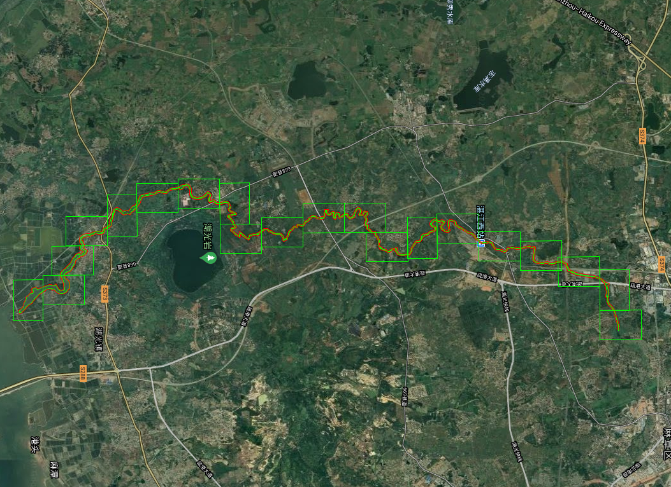
旧县河总图 | 指北针 | 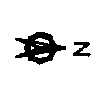

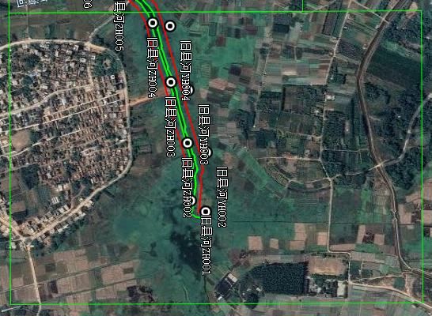
旧县河河道管理范围线平面布置图（1/20） | 指北针
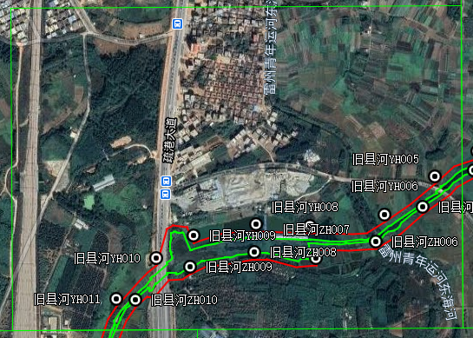
旧县河河道管理范围线平面布置图（2/20） | 指北针
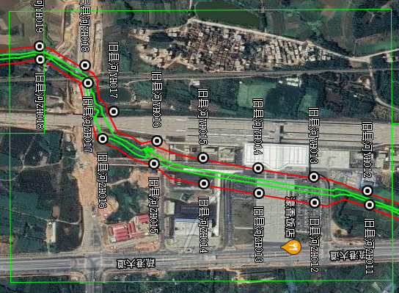
旧县河河道管理范围线平面布置图（3/20） | 指北针
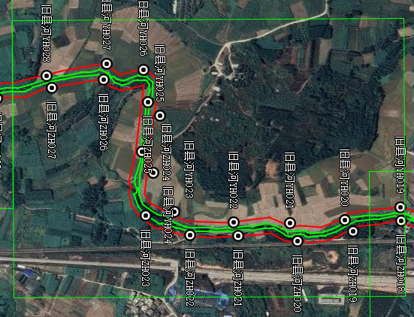
旧县河河道管理范围线平面布置图（4/20） | 指北针
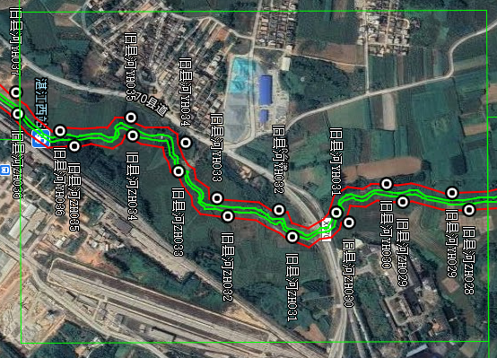
旧县河河道管理范围线平面布置图（5/20） | 指北针
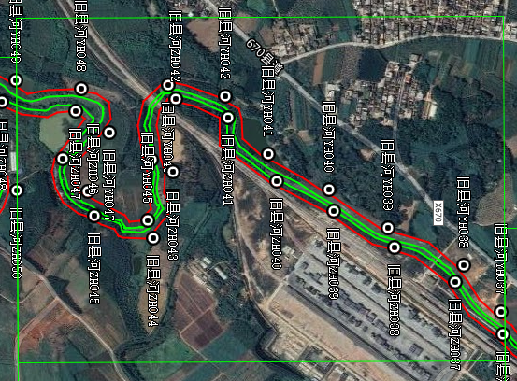
旧县河河道管理范围线平面布置图（6/20） | 指北针
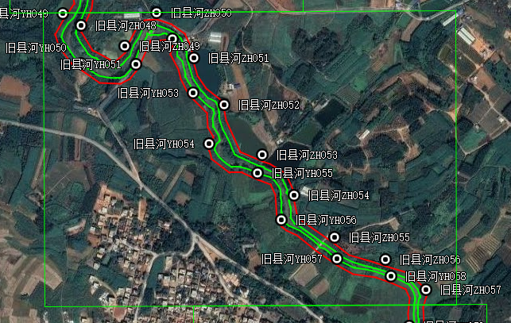
旧县河河道管理范围线平面布置图（7/20） | 指北针
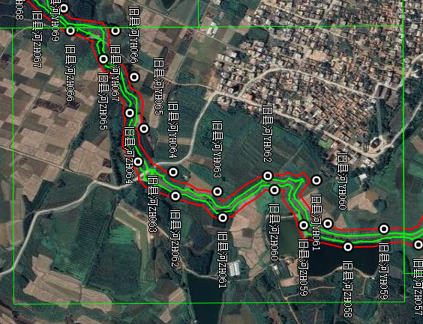
旧县河河道管理范围线平面布置图（8/20） | 指北针
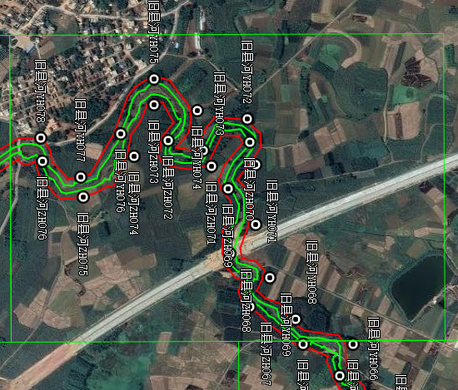
旧县河河道管理范围线平面布置图（9/20） | 指北针
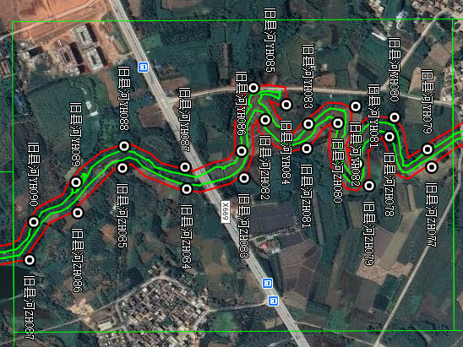
旧县河河道管理范围线平面布置图（10/20） | 指北针
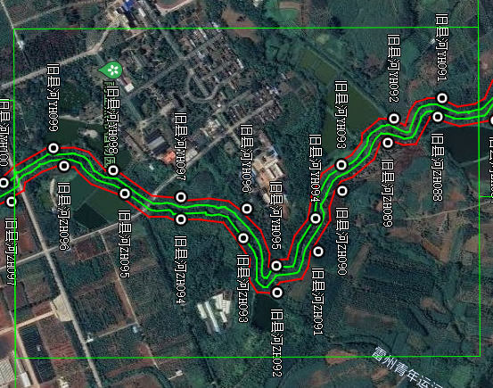
旧县河河道管理范围线平面布置图（11/20） | 指北针
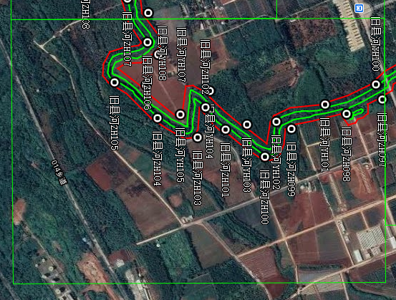
旧县河河道管理范围线平面布置图（12/20） | 指北针
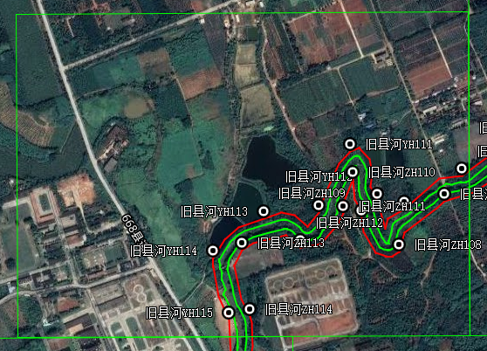
旧县河河道管理范围线平面布置图（13/20） | 指北针
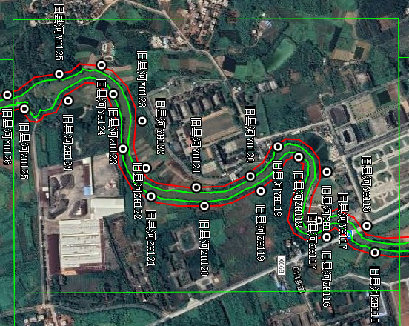
旧县河河道管理范围线平面布置图（14/20） | 指北针
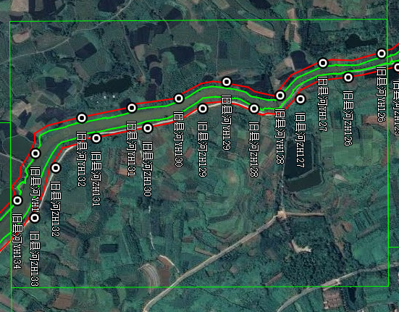
旧县河河道管理范围线平面布置图（15/20） | 指北针
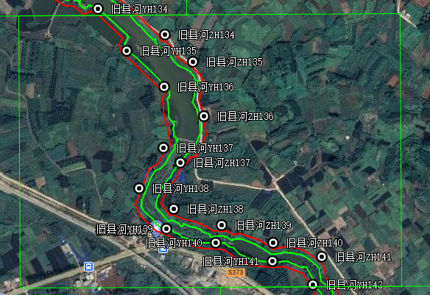
旧县河河道管理范围线平面布置图（16/20） | 指北针
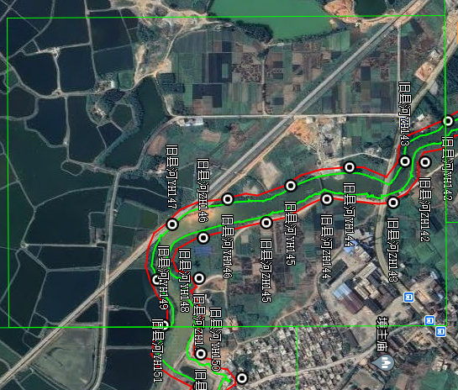
旧县河河道管理范围线平面布置图（17/20） | 指北针
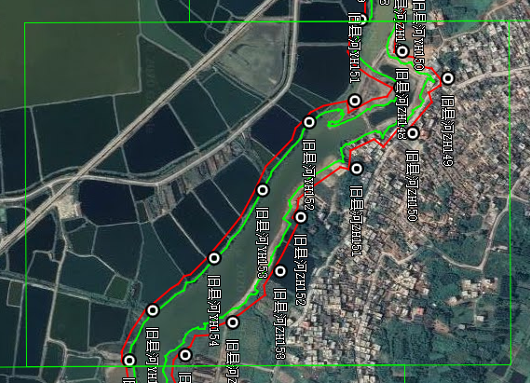
旧县河河道管理范围线平面布置图（18/20） | 指北针
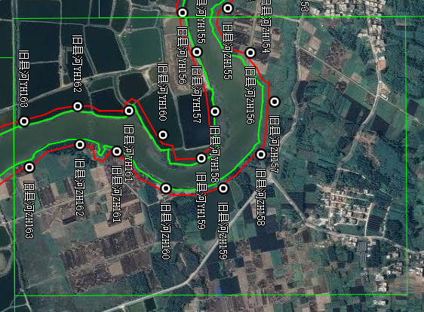
旧县河河道管理范围线平面布置图（19/20） | 指北针
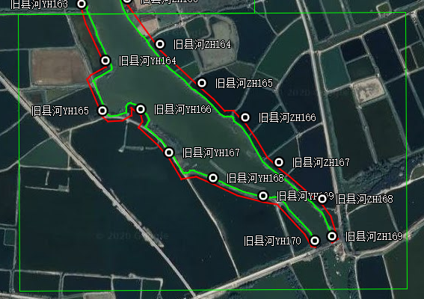
旧县河河道管理范围线平面布置图（20/20） | 指北针

